SCL TAPEOUT SUBMISSION FORM THROUGH CHIPIN CENTRE



SEMICONDUCTOR LABORATORY
SECTOR 72, S.A.S. NAGAR
(NEAR CHANDIGARH)
PUNJAB – 160071

This document provides information on various items, which must be considered when a layout is provided to ChipIN Centre, C-DAC Bangalore to fabricate through Semi-Conductor Laboratory (SCL) for processing with 180nm CMOS technology.

TABLE OF CONTENTS

Table of contents ………………………………………………………………………….…………………….2

General Guidelines …….……………………………………………………………………....................3

Product Related Information

Customer Information .....................……………………………………………………………… 5

Project Information .................………….…………………………………………………….…… 5

Check List ………………………….……………………………………………………………….………… 7

Reports to be included ..................................................................................... 8
- Guidelines/ Notes for tape-out and packaging ……………………………………………… 9

General Guidelines
Please follow carefully all the guidelines given herein to ensure correct and timely processing of your Designs/Circuits.

  - Data Format and Communication:

    - Acceptable database format is GDSII only.
    - Complete database must be sent through e-mail to ‘chipin@cdac.in’. Do not provide any google drive link.
    - The communication has to be addressed through mail at:
To: chipin@cdac.in
CC: venkatark@cdac.in, viviand@cdac.in, support.c2s@meity.gov.in
ChipIN Centre,
Chips to Start-up (C2S) Programme,
C-DAC Bangalore,
Opp. HAL Aeroengine Division,
Old Madras Road, Byappanahalli,
Bengaluru - 560 038.

  - Layout Grid

    - Minimum grid size used in the GDSII must be integer multiple of 0.005µm.
    - Final GDSII window (including seal ring) must have Bottom left corner at (0,0) coordinate and the Top-Right corner coordinate must be rounded off to closest even number and it should be without any decimal places i.e., 10102 µm or 10100 µm for the case if coordinate comes at 10101.395 µm.

  - Design Kit
    - Do not rename cell names used in cell library.
    - Do not use library cell name for custom designed cells.
    - Do not edit standard cell library and I/O library.

  - Design Verification

    - Customers must provide a clean GDSII database w.r.t. DRC, Density and Antenna rules.
    - Before taping out the data, please provide checksum for GDSII file. Save the checksum value and byte count in a file, so that the same can be crosschecked at our end. e.g. cksum EDU0001_01012016_v1.gds 12345678 204 EDU0001_01012016_v1.gds
    - For GDSII integrity check while data transfer MD5 checksum is must and need to be provided in addition to checksum so that the same can be crosschecked at our end. For calculating MD5, Just open Linux terminal and type: md5sum ‘filename’ e.g. md5sum SC0001-0E_25012023_v1.gds
    - GDSII name and Top cell name format: silicon_no_date_version.gds (date format should be ddmmyyyy) and top cell name should be "silicon number" only.

    - All the reports should be named as GDSII name.
Eg: silicon no_date_version_drc.rpt, silicon no_date_version_drc.summary, silicon no_date_version_ant.rpt etc.

    - Process Information Sheet (PIS sheet): All the columns must be filled with the drop-in information wherever provided. At places where drop-in is not given, designer must write as per the column description only.

Product Related Information

- Customer Information
Name of the Organization : PES University
Contact Person & Designation : Mahesh Awati , Associate Professor
Tel./Mob. : 9741172822
Email : mahesha@pes.edu
- Project Information
  - Product/Design name : DL FPU
    - Silicon Number (Issued by SCL) : C2S0110
  - Brief Description of the circuit :
- The Deep Learning Floating Point Unit (DL-FPU) supports Addition, Subtraction, Multiplication, Division, Square Root, Multiply-Accumulate (MAC) ,Euclidean norm and Dot product operations based on IBM’s DL Floating-Point representation.
- The MAC unit internally contains both an Adder and a Multiplier, optimizing performance for accumulate-based operations.
- This DL-FPU is designed to operate at a maximum frequency of 10 MHz.
- A 8:1 multiplexer is used to select the output from the four functional units (Adder, Multiplier, Divider, and MAC), controlled by a 3-bit select signal (sel).

  - Physical Design (layout) EDA Tool name and Version (Please specify) :
Cadence Genus Synthesis Solution version: 20.11-s111_1
Cadence Innovus Implementation System version: 20.14-s095_1
Cadence Virtuoso version: 6.1.8-64b
Calibre Interactive version: v2022.4_37.20

  - Top cell Name : C2S0110
  - Die coordinates with seal ring (µm) X min: 0 X max: 2000
Y min: 0 Y max: 2000

  - Silicon Number Co-ordinates X min: 313.81 X max: 326.84
Y min: 525.62 Y max: 703.31
  - Die Size (µm) : 2000 x 2000
  - GDSII File Name : C2S0110_26082025_v4.gds
  - GDSII File Size in bytes : 29622272
  - GDSII Checksum : 887398502 29622272 C2S0110_26082025_v4.gds
  - GDSII MD5 value : 4110ce8ecf51764c80650ff337031e9c C2S0110_26082025_v4.gds
2.11 SCL PDK (Name, Version and revision): SCL PDK v3

2.12 | Standard cell library: |  | fs120 | ✔
2.13 | IO library: |  | cio150 | ✔ | cio250 |  | pio520
2.14 | Metal level: |  | 4M1L | ✔ | 6M1L
 | IO voltage: |  | 1.8V Only | ✔ | 3.3V Only |  | 5V Only
2.15 | IO voltage:
 | IO voltage: |  | 1.8V & 3.3V |  | 1.8V & 5V
 | Core voltage: |  | 1.8V Only | ✔ | 3.3V Only |  | 5V Only
2.16 | Core voltage:
 | Core voltage: |  | 1.8V & 3.3V |  | 1.8V & 5V
2.17 | Mosfets type (core only): |  | 1.8V | ✔ | 3.3V |  | 5V
2.18 | Device Application:
- Custom Floating Point Processing Unit designed for deep learning and AI workloads, implementing IBM DLFloat format.

Note: 3.3V and 5V transistors are not allowed in a single design because this is an illegal combination. For more info regarding all such type of allowed and illegal combination, please refer PDK ReadMe.

- Tapeout Checklist

Device related information | Yes/No
GDSII database provided | Yes
Silicon Number with PCI is mandatory. GDSII for this is included in the PDK.  (Layer revision block may be placed if space permit) ? | Yes
Seal Ring with GND connection inserted? | Yes
Is DRC along with dummy fill Report clean? | Yes
Is Antenna along with dummy fill Report clean? | Yes
Dummy Fill done | Yes
Grid size 0.005µm used for layout | Yes
Whether Pads connected till top metal (TOP_M) ? | Yes
Final Chip Origin should be at (0,0) after seal ring insertion. | Yes
Process Information Sheet duly filled? | Yes

- Reports to be included (please √ on the following if provided)

Final DRC run Reports (Result database including density logs, summary, transcript, runset version) | ✔
Final Antenna Report (Result database, summary, transcript, runset version) | ✔
Devices type (or legal devices) used in layout report | ✔
Stream out log files | ✔
List of third party IP used (If any with prior approval from SCL)
List of SCL IP used (If any with prior approval from SCL)
List of all legal layers used before silicon number insertion in Excel Format  (Layer Name + layer number + datatype) | ✔
Coordinate of Silicon number | ✔
Process Information Sheet (Attached PIS Excel) | ✔

Note: Prior to final submission of GDSII please contact ChipIN Team for insertion of Silicon Number Structure in layout at your end. Silicon Number will be generated by SCL PDK Team as per SCL Numbering System through ChipIN Centre. Contact Emails for obtaining Silicon Number: chipin@cdac.in.

- Guidelines/ Notes for packaging

  - Bonding diagram also shall be submitted along with the design submission for fabrication.
  - Followings need to be ensured by ChipIN center during the submission of any GDSII to SCL
    - The bonding diagram has been generated and verified
    - All the packaging related data/files based on the final bonding diagram must be submitted in the final data pack

Tape-out and Packaging related Checklist |  | Please Tick / Specify
Mention the Die size including seal ring. Options supported: 2 x 2 mm², 3 x 3 mm² , 4 x 4 mm² or 5 x 5 mm²  (No other size is supported in the current tapeout under this program) For sizes greater than 5 x 5 mm ² ChipIN will contact SCL’s PPG. |  | 2 x 2 mm²
The design should have a seal ring around it. The distance between chip boundary to seal ring should be minimum of 10um with DRC Clean |  | ✔
The seal ring is connected to VSS (Ground) |  | ✔
No. of pins for Packaging the IC  (Currently no. of pins should not be more than 100 for packaging) |  | 64
Package selected for packaging (Refer Appendix – I) | Specify the Package Serial Number | 18.0 x 18.0  10
The minimum pitch between two adjacent bond pads is 90um for all bond pads |  | ✔

Any other Remarks from Designer/Reviewer:

Chethan Reddy G N
 Dr. Madhura P
Name and Signature of the Designer Name and Signature of the Reviewer/Approving Authority
(PI / Co-PI of the Institution)
Date and Seal:

APPENDIX - I
Preferred Die Size and plastic packages (Chip-on-Board<CoB> Packaging Options)
Sr. No. | Die Size (mm) | Package Size (mm) | Pin Count | Package Lead Pitch (mm) | CoB Package Type
1 | 2.0 x 2.0 | 7.0 x 7.0 | 16 | 1.0 | QFN
2 | 3.0 x 3.0 | 7.0 x 7.0 | 16 | 1.0 | QFN
3 | 2.0 x 2.0 | 8.4 x 8.4 | 24 | 1.0 | QFN
4 | 3.0 x 3.0 | 8.4 x 8.4 | 24 | 1.0 | QFN
5 | 3.0 x 3.0 | 9.0 x 9.0 | 28 | 1.0 | QFN
6 | 2.0 x 2.0 | 10.0 x 10.0 | 32 | 1.0 | QFN
7 | 3.0 x 3.0 | 10.0 x 10.0 | 32 | 1.0 | QFN
8 | 2.0 x 2.0 | 14.0 x 14.0 | 48 | 1.0 | QFN
9 | 3.0 x 3.0 | 14.0 x 14.0 | 48 | 1.0 | QFN
10 | 2.0 x 2.0 | 18.0 x 18.0 | 64 | 1.0 | QFN
11 | 3.0 x 3.0 | 18.0 x 18.0 | 64 | 1.0 | QFN
12 | 4.0 x 4.0 | 14.0 x 14.0 | 48 | 1.0 | QFN
13 | 5.0 x 5.0 | 14.0 x 14.0 | 48 | 1.0 | QFN
14 | 4.0 x 4.0 | 18.0 x 18.0 | 64 | 1.0 | QFN
15 | 5.0 x 5.0 | 18.0 x 18.0 | 64 | 1.0 | QFN
16 | 4.0 x 4.0 | 10.0 x10.0 | 72 | 1.0 | QFN
17 | 5.0 x 5.0 | 20.0 x 20.0 | 72 | 1.0 | QFN
18 | 4.0 x 4.0 | 20.0 x 20.0 | 80 | 1.0 | QFN
19 | 5.0 x 5.0 | 20.0 x 20.0 | 80 | 1.0 | QFN
20 | 4.0 x 4.0 | 25.0 x 25.0 | 88 | 1.0 | QFN
21 | 5.0 x 5.0 | 25.0 x 25.0 | 88 | 1.0 | QFN
22 | 4.0 x 4.0 | 28.0 x 28.0 | 100 | 1.0 | QFN
23 | 5.0 x 5.0 | 28.0 x 28.0 | 100 | 1.0 | QFN

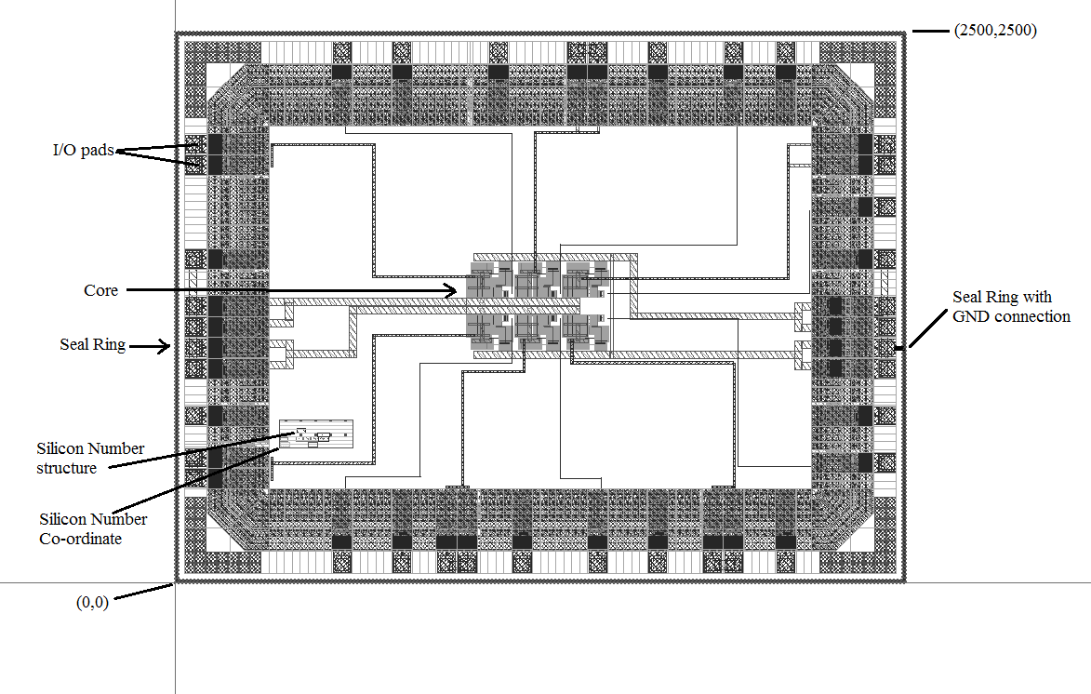
Example Design:

Example package:
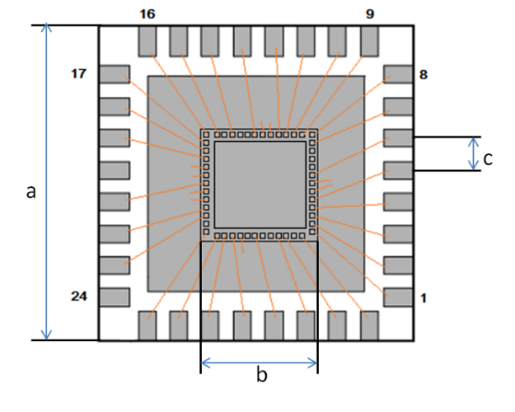
Label Name | Indicators
a | Package Size
b | Die Attach Pad Size
c | Package Lead Pitch

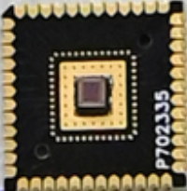
QFN Type CoB Package

